**Ubuntu MAAS Test Report**

Contents

1 Overview 3

2 Test Result Summary 3

3 Preparing for the MAAS Environment 3

4 Verifying the System Power-On and Power-Off (IPMI Mode) 8

4.1 Verifying the System Power-Off 8

4.2 Verifying the System Power-On 10

5 Querying Drive, CPU, Memory, and Hardware Information 12

6 Deploying the PXE System 14

7 Deploying the Image System 15

# Overview

This document describes how to use the Ubuntu MAAS bare-metal management system to test MAAS functions on different types of XFUSION hardware.

# Test Result Summary

The following table lists the test results.

|  |  |  |
| --- | --- | --- |
| Hardware Type  MAAS Function | V3 rack server | V5 rack server |
| System power-on and power-off (IPMI) | Supported | Supported |
| Drive, CPU, and memory information query | Supported | Supported |
| PXE system deployment | Supported | Supported |
| OS deployment | Supported | Supported |

# Preparing for the MAAS Environment

1. Configure the connection to the Internet.

Set the public IP address, subnet mask, gateway, and DNS server to ensure that you can access the Internet. You can run the **ping archive.ubuntu.com** command to verify the configuration, as shown in the following figures.

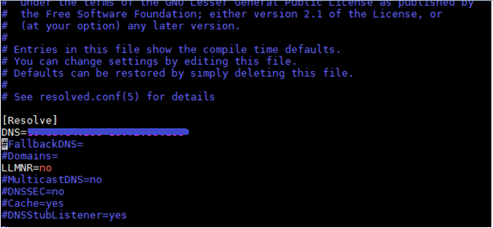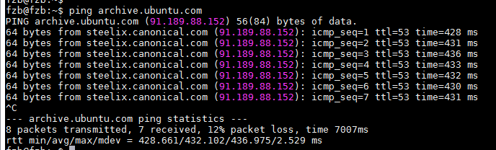

2. Download the image I/O from the official website to the MAAS server.

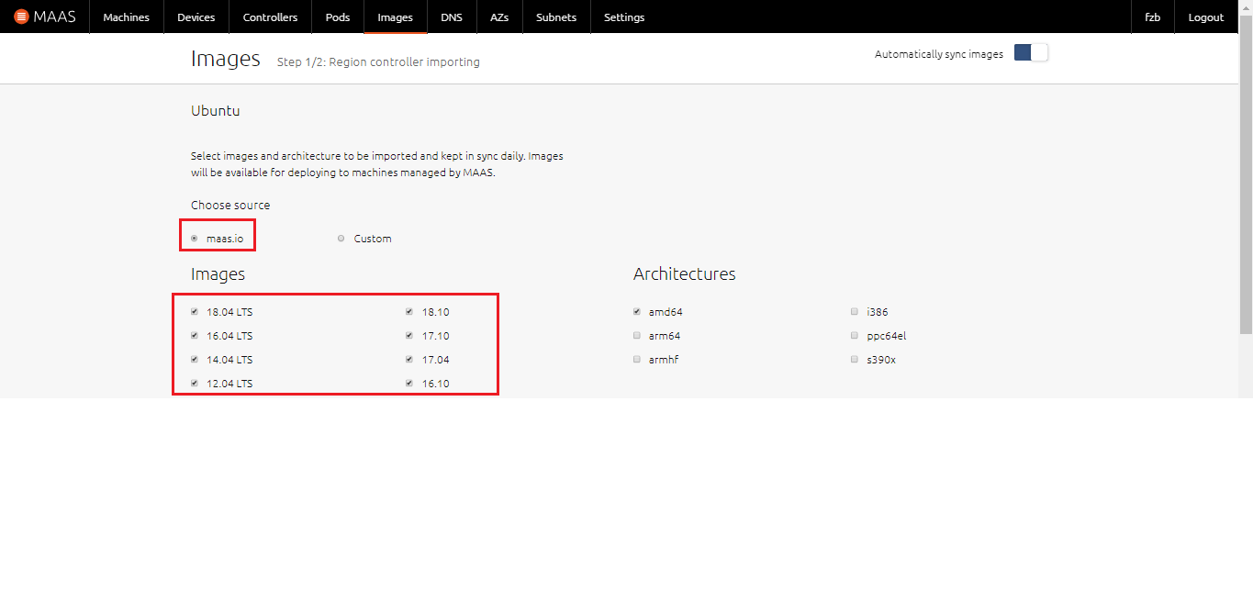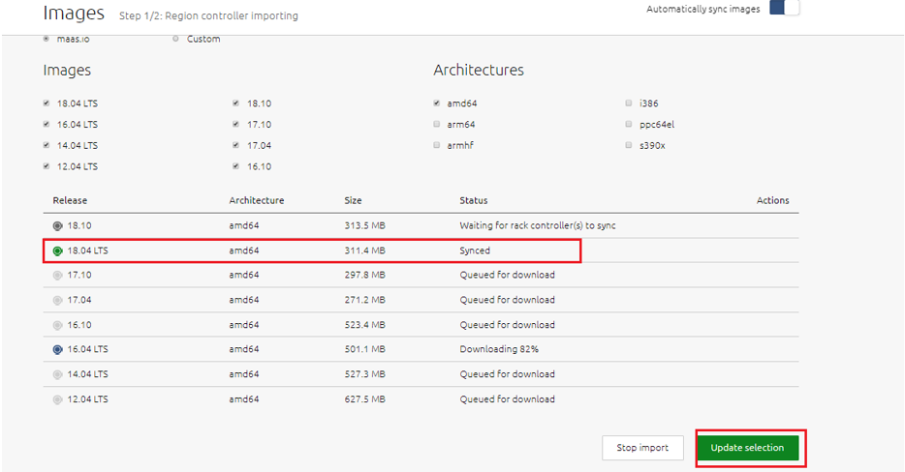

3. If the DHCP does not exist in the network, enable the DHCP function of MAAS.

(1) Choose **Subnets** > **untagged** to go to the VLAN configuration page.

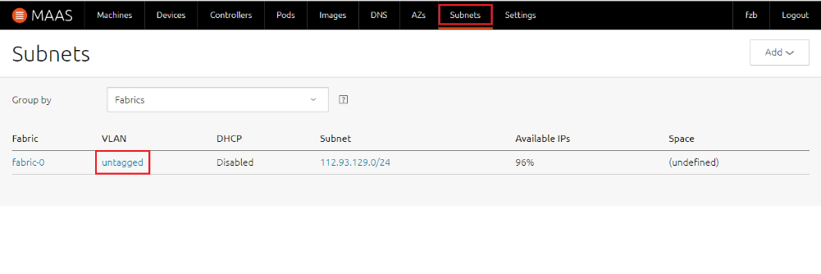

(2) Choose **Take action** > **Provide DHCP**, and set the rack controller, start IP address, end IP address, and subnet mask of the DCHP function.

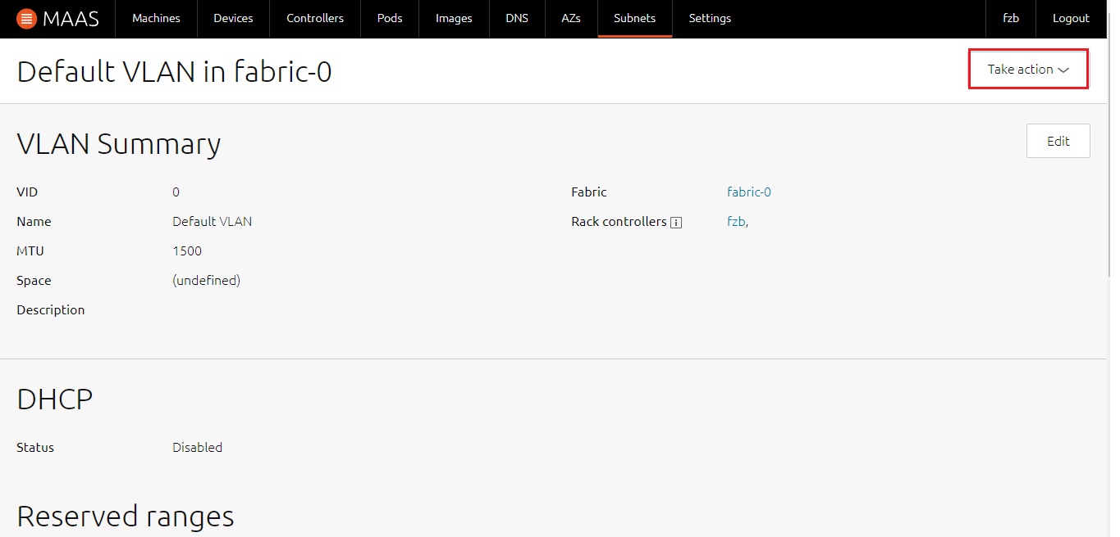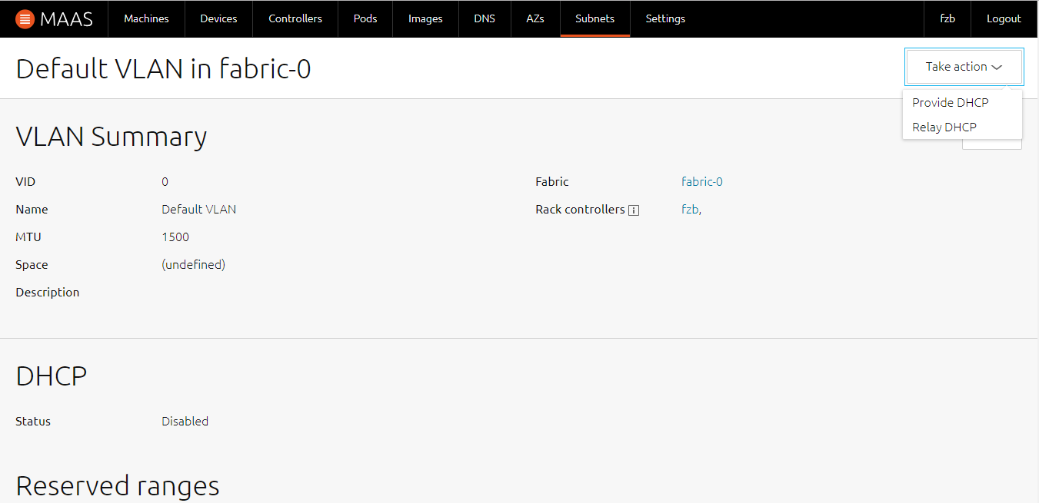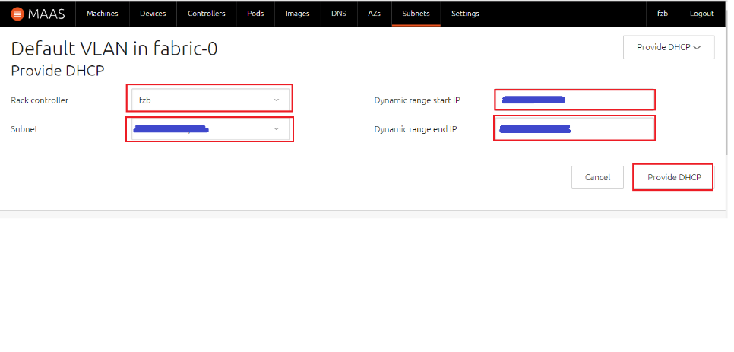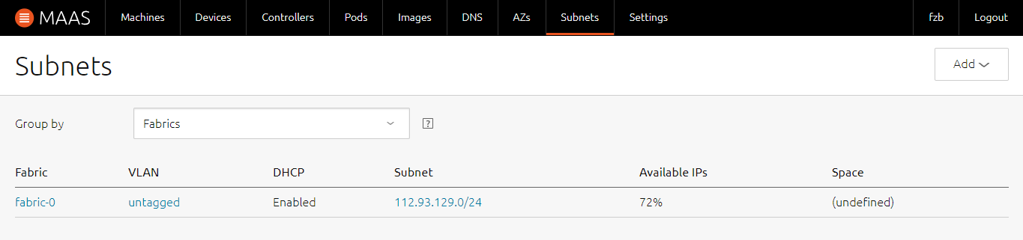

4. Set the MAC address for the server to be deployed, set the power control mode, and add the server to MAAS management.

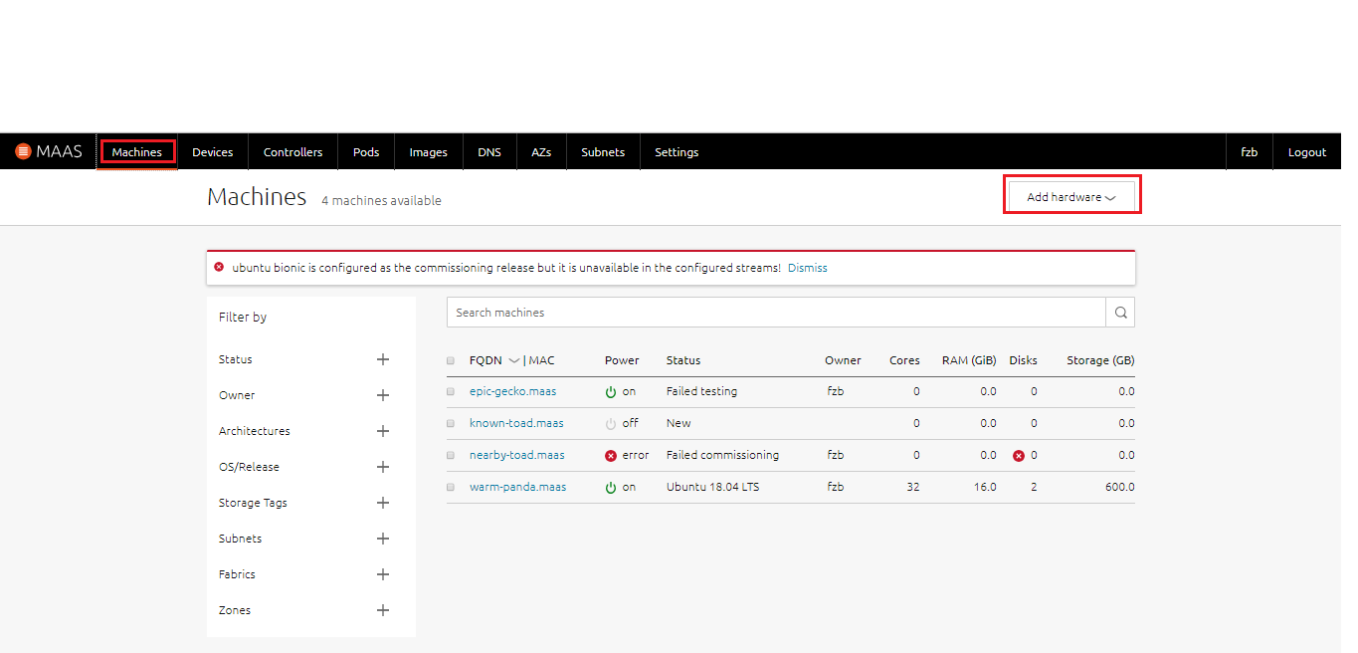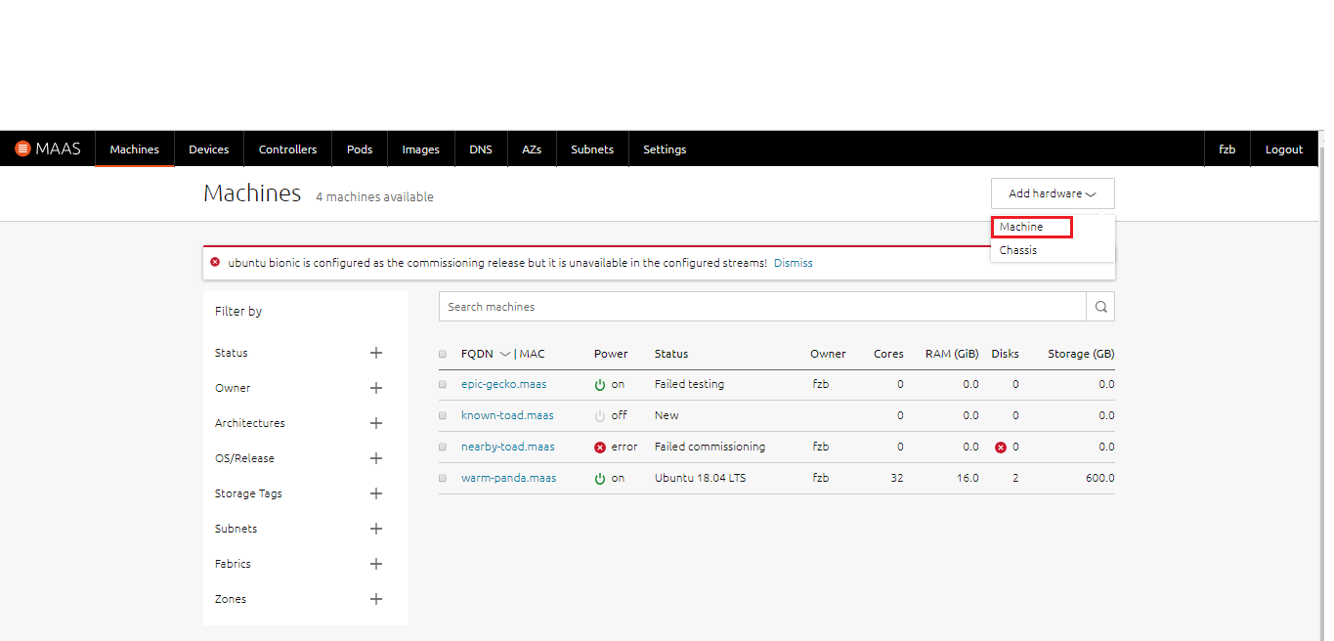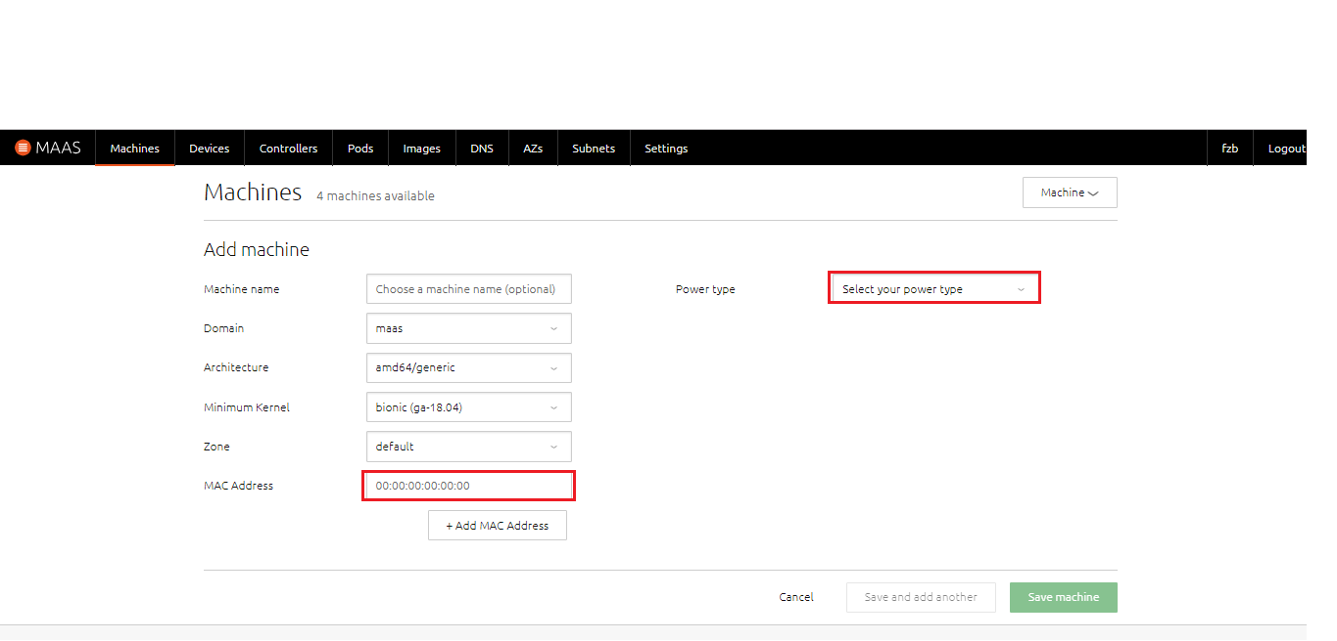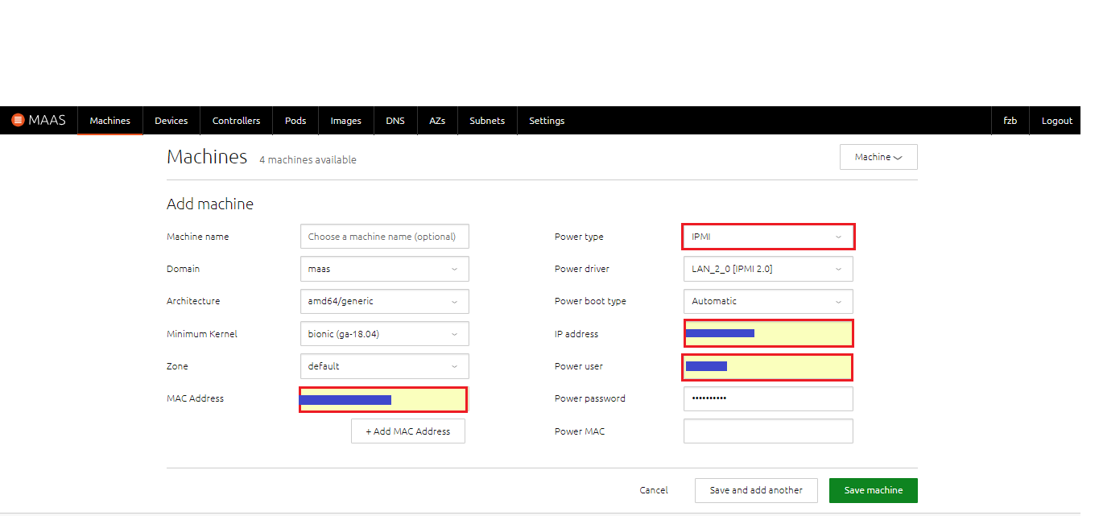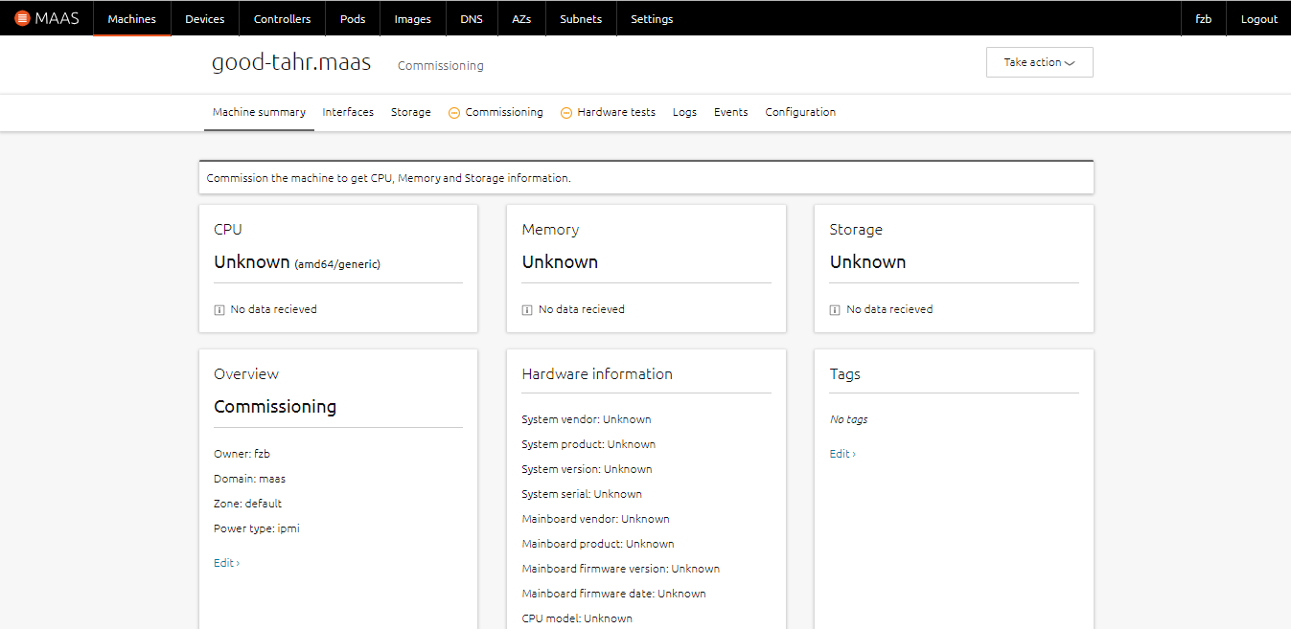

5. Select the PXE deployment I/O and image installation I/O.

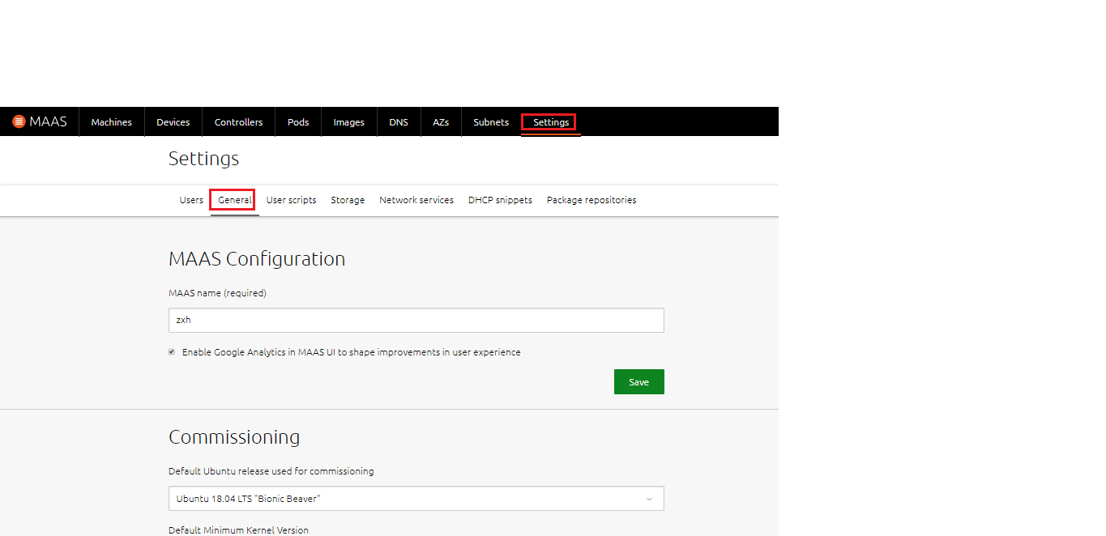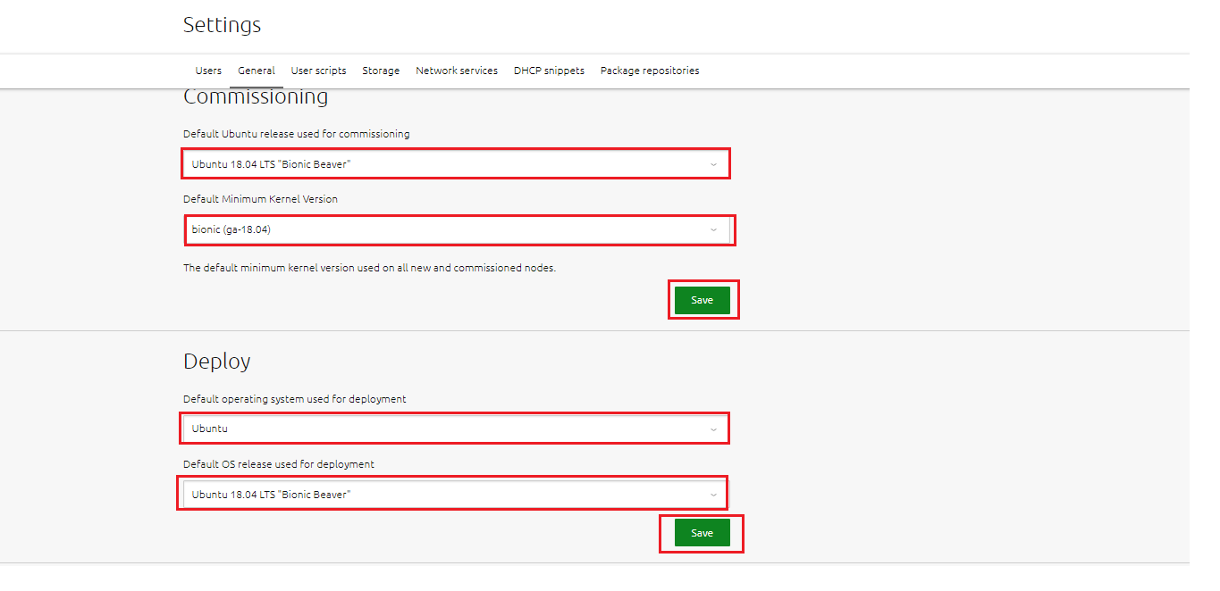

# Verifying the System Power-On and Power-Off (IPMI Mode)

## Verifying the System Power-Off

After setting **Power type** to **IPMI** on MAAS, you can power off a server directly.

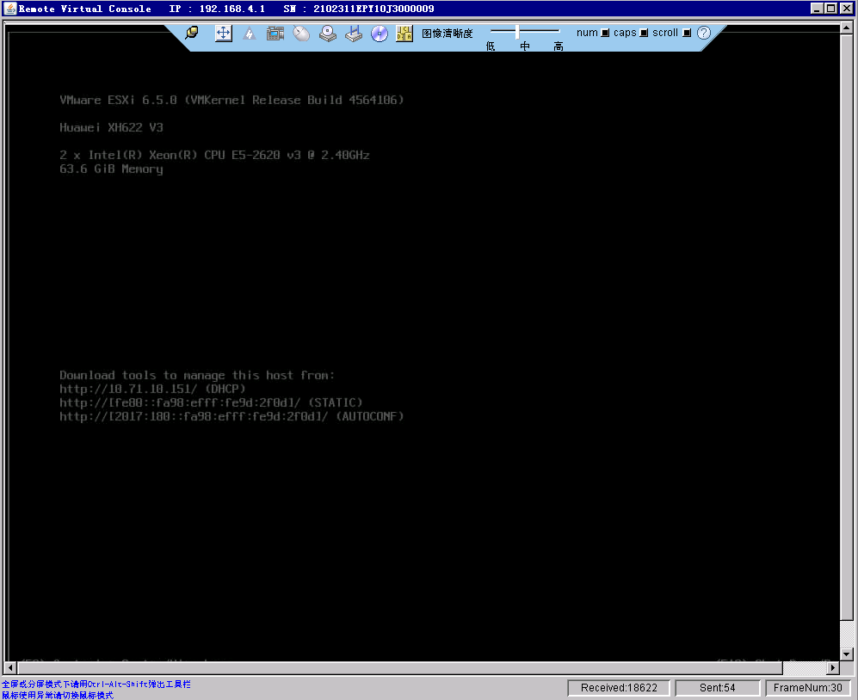

(1) On the **Machines** page, choose **Take action** > **Power off** to power off a server.

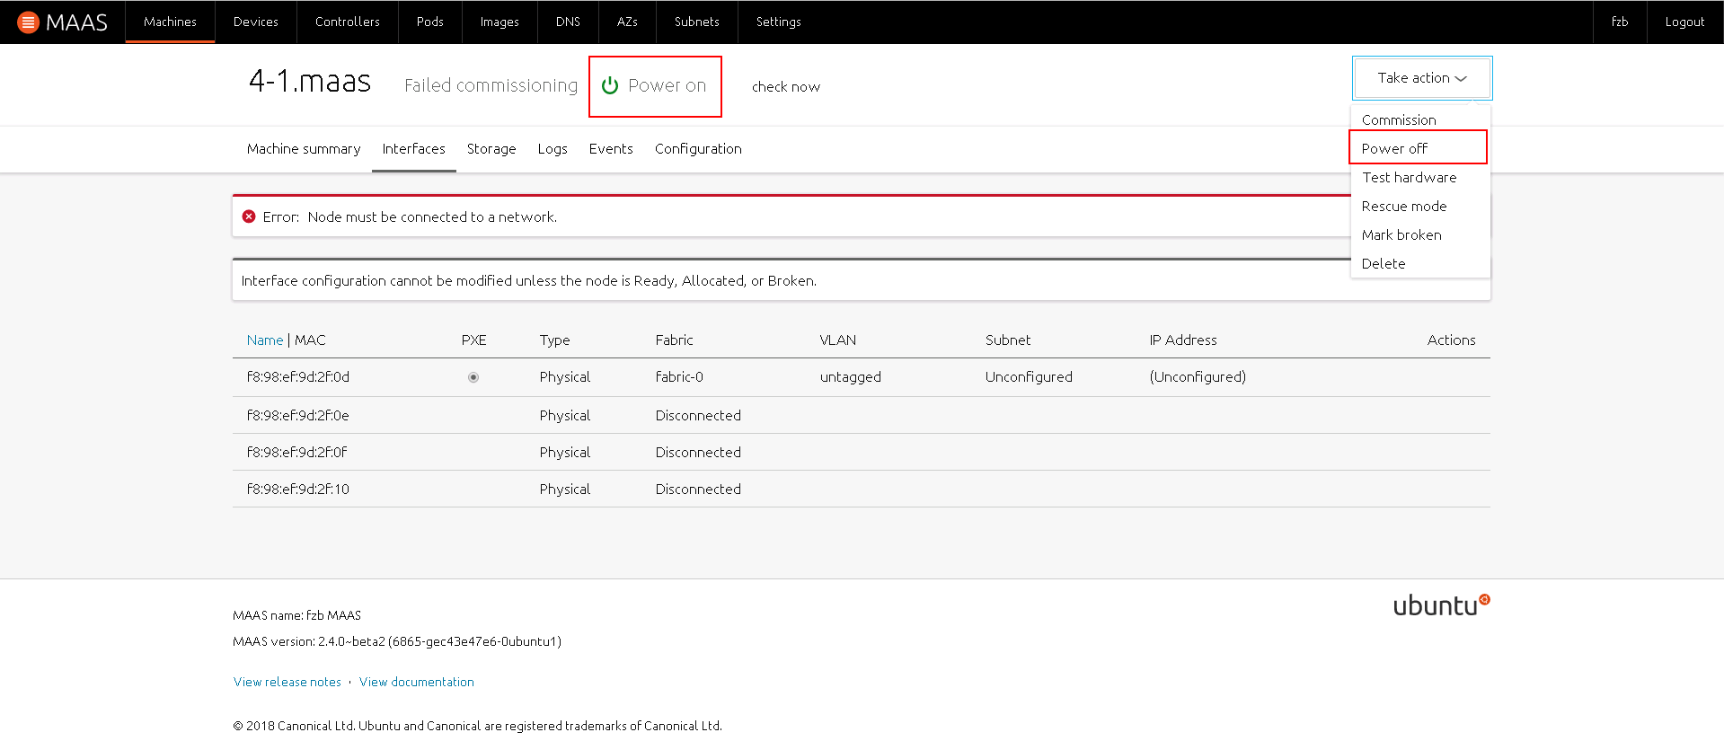

(2) In the displayed drop-down list box, click **Power off machine**.

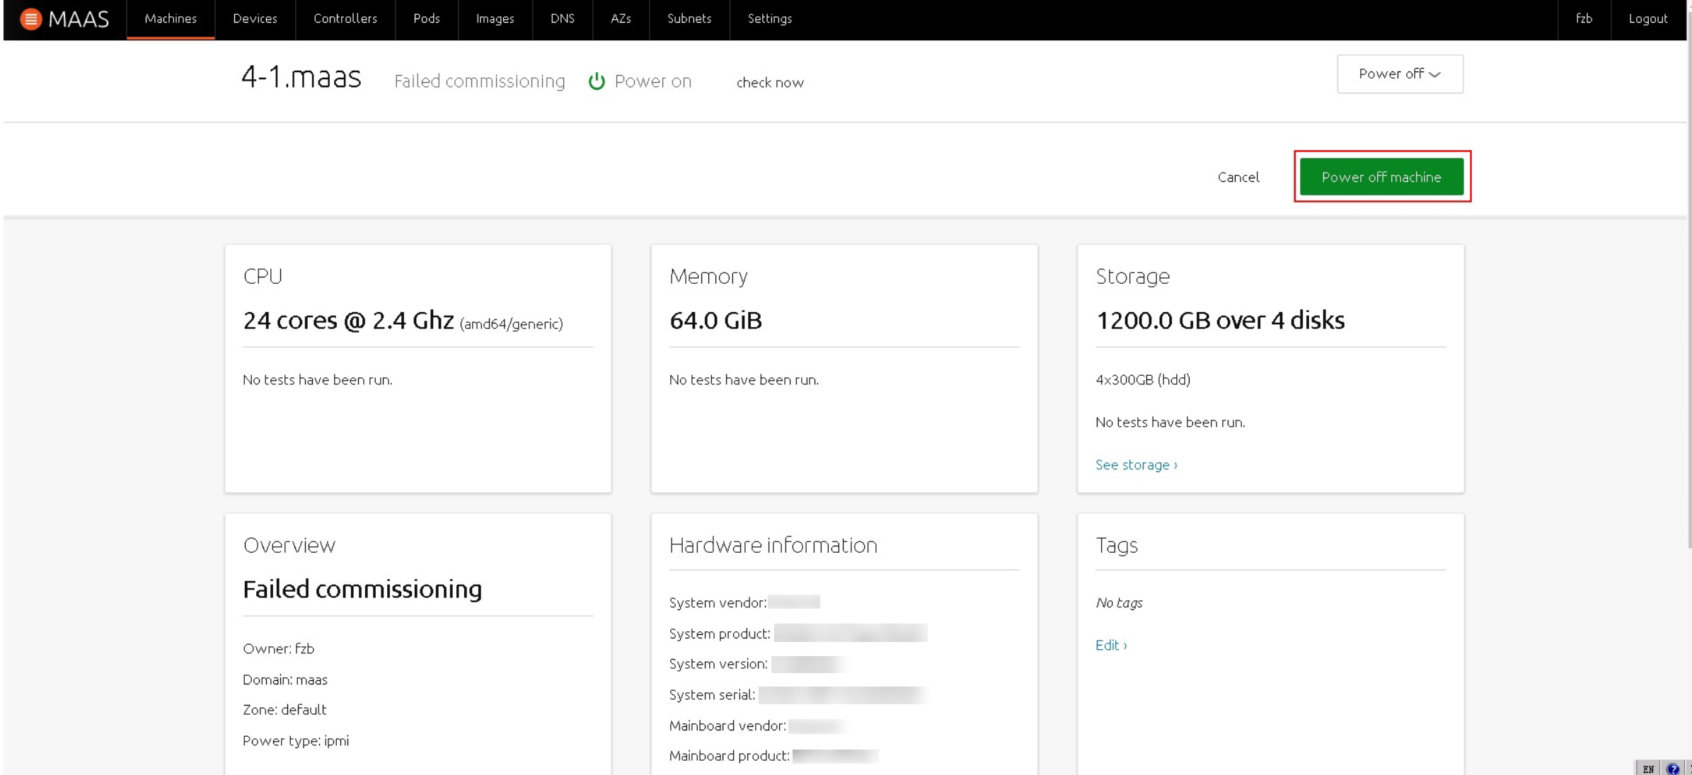

(3) Wait a few minutes. The operation is successful when the power status changes to **Power off**.

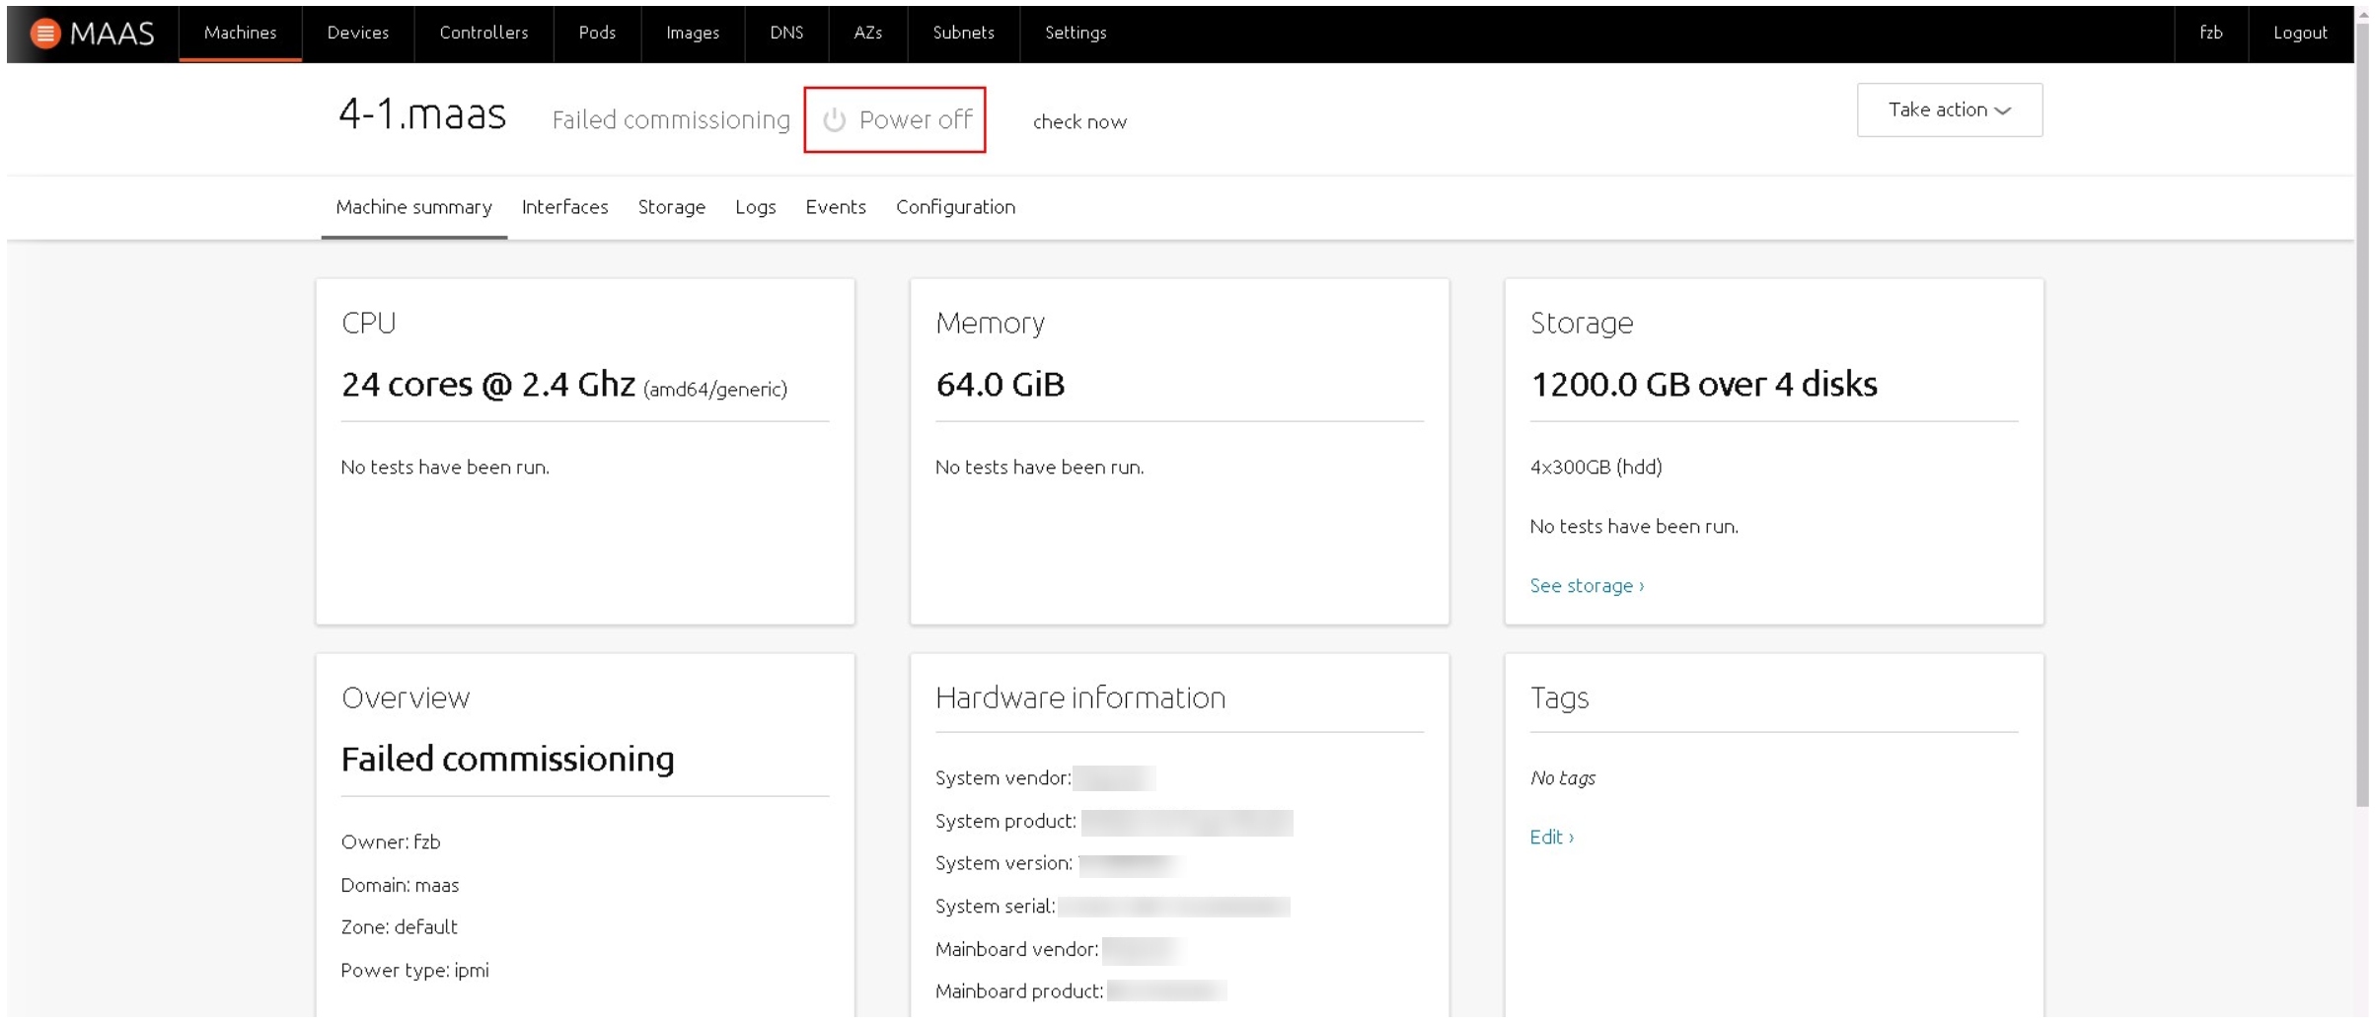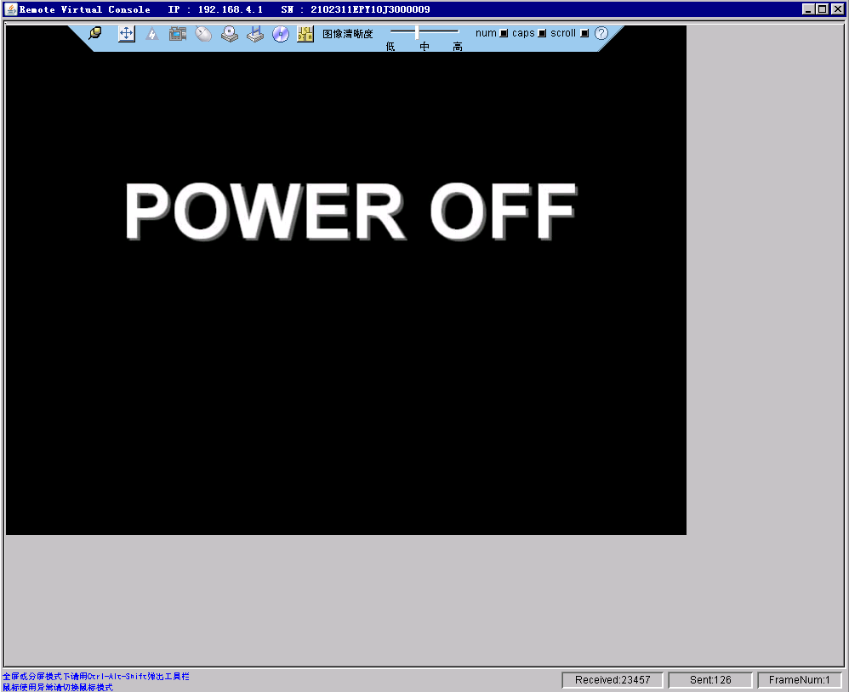

## Verifying the System Power-On

A server system can be powered on by using MASS only after MAAS is installed on the server.

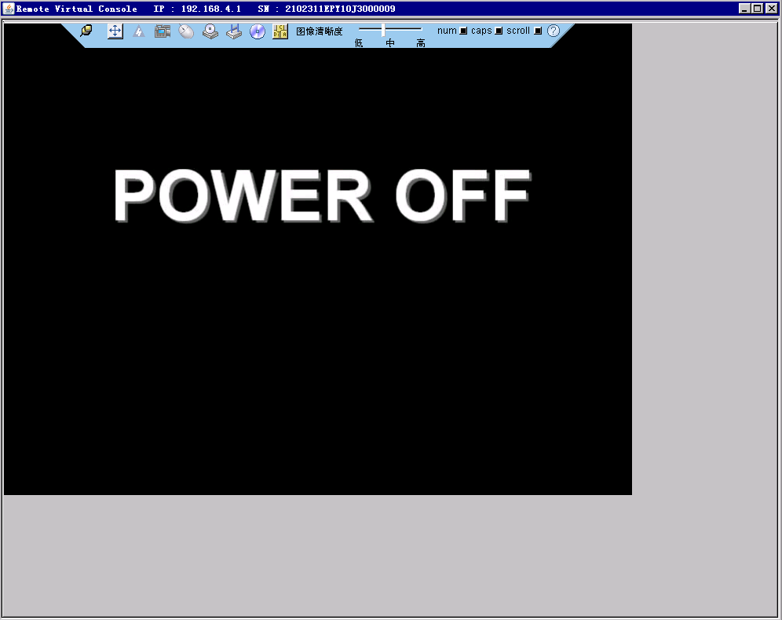

For a server system where MAAS is installed successfully, choose **Take action** > **Power on**.

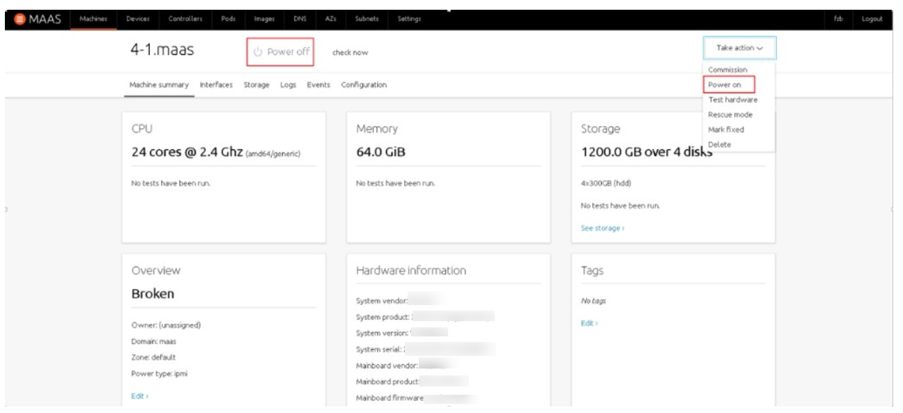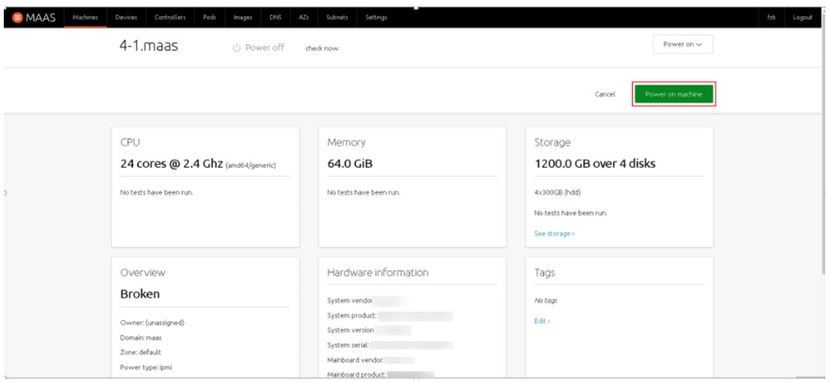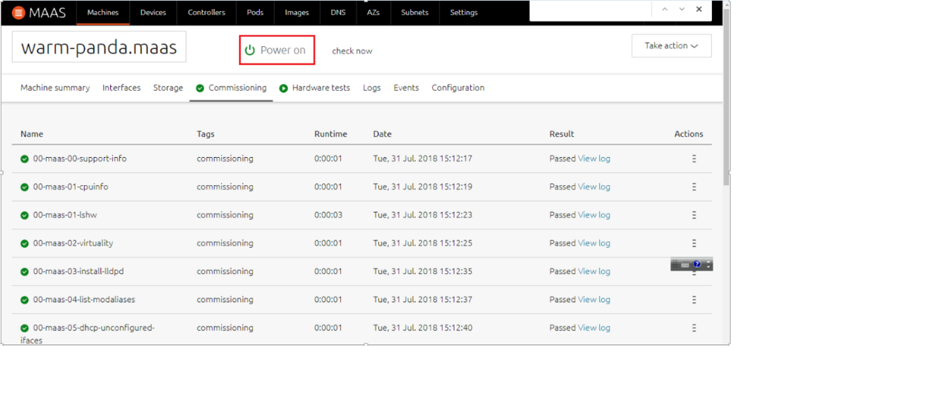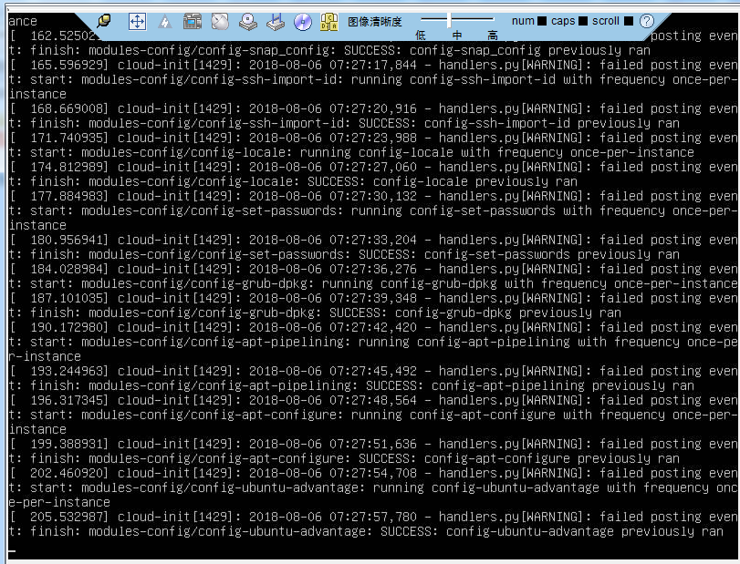

# Querying Drive, CPU, Memory, and Hardware Information

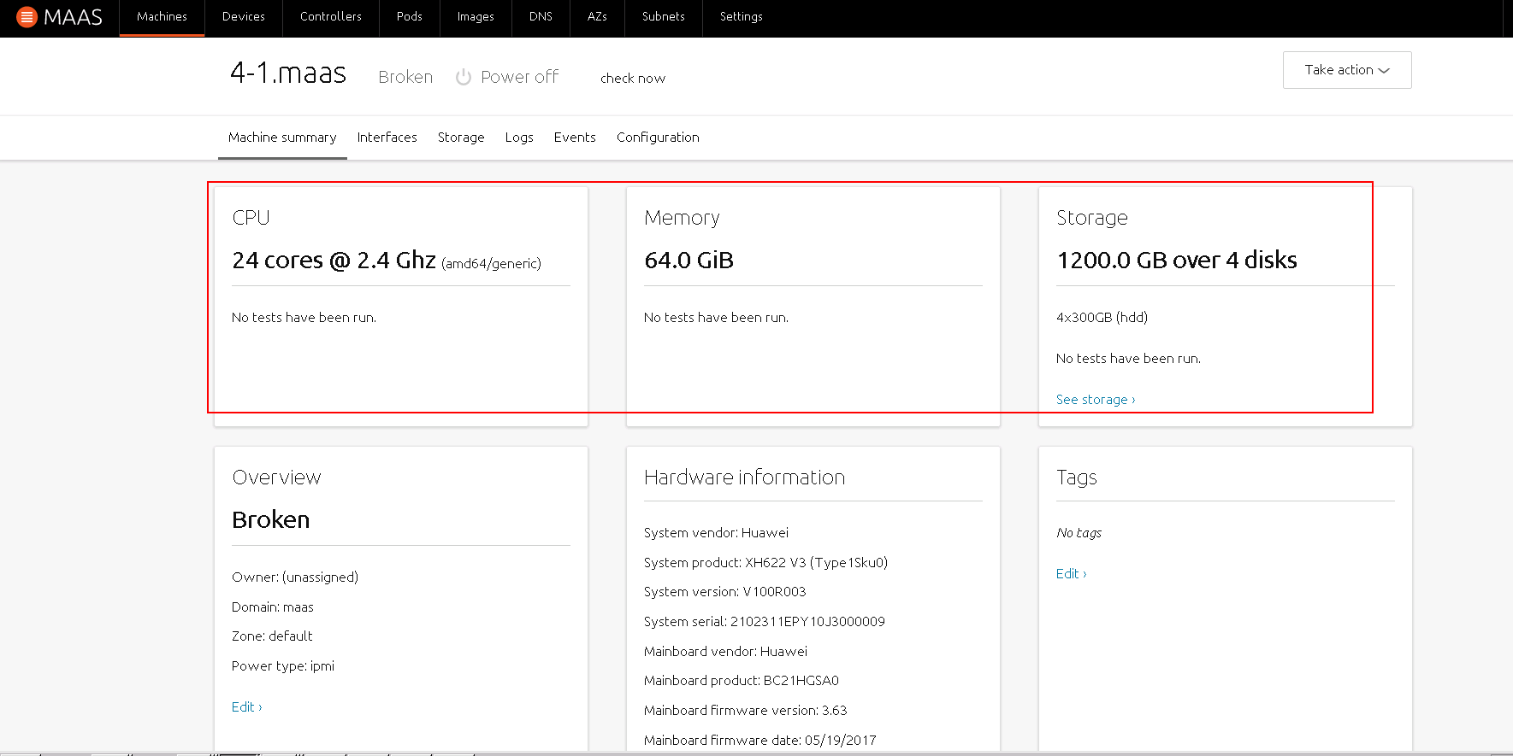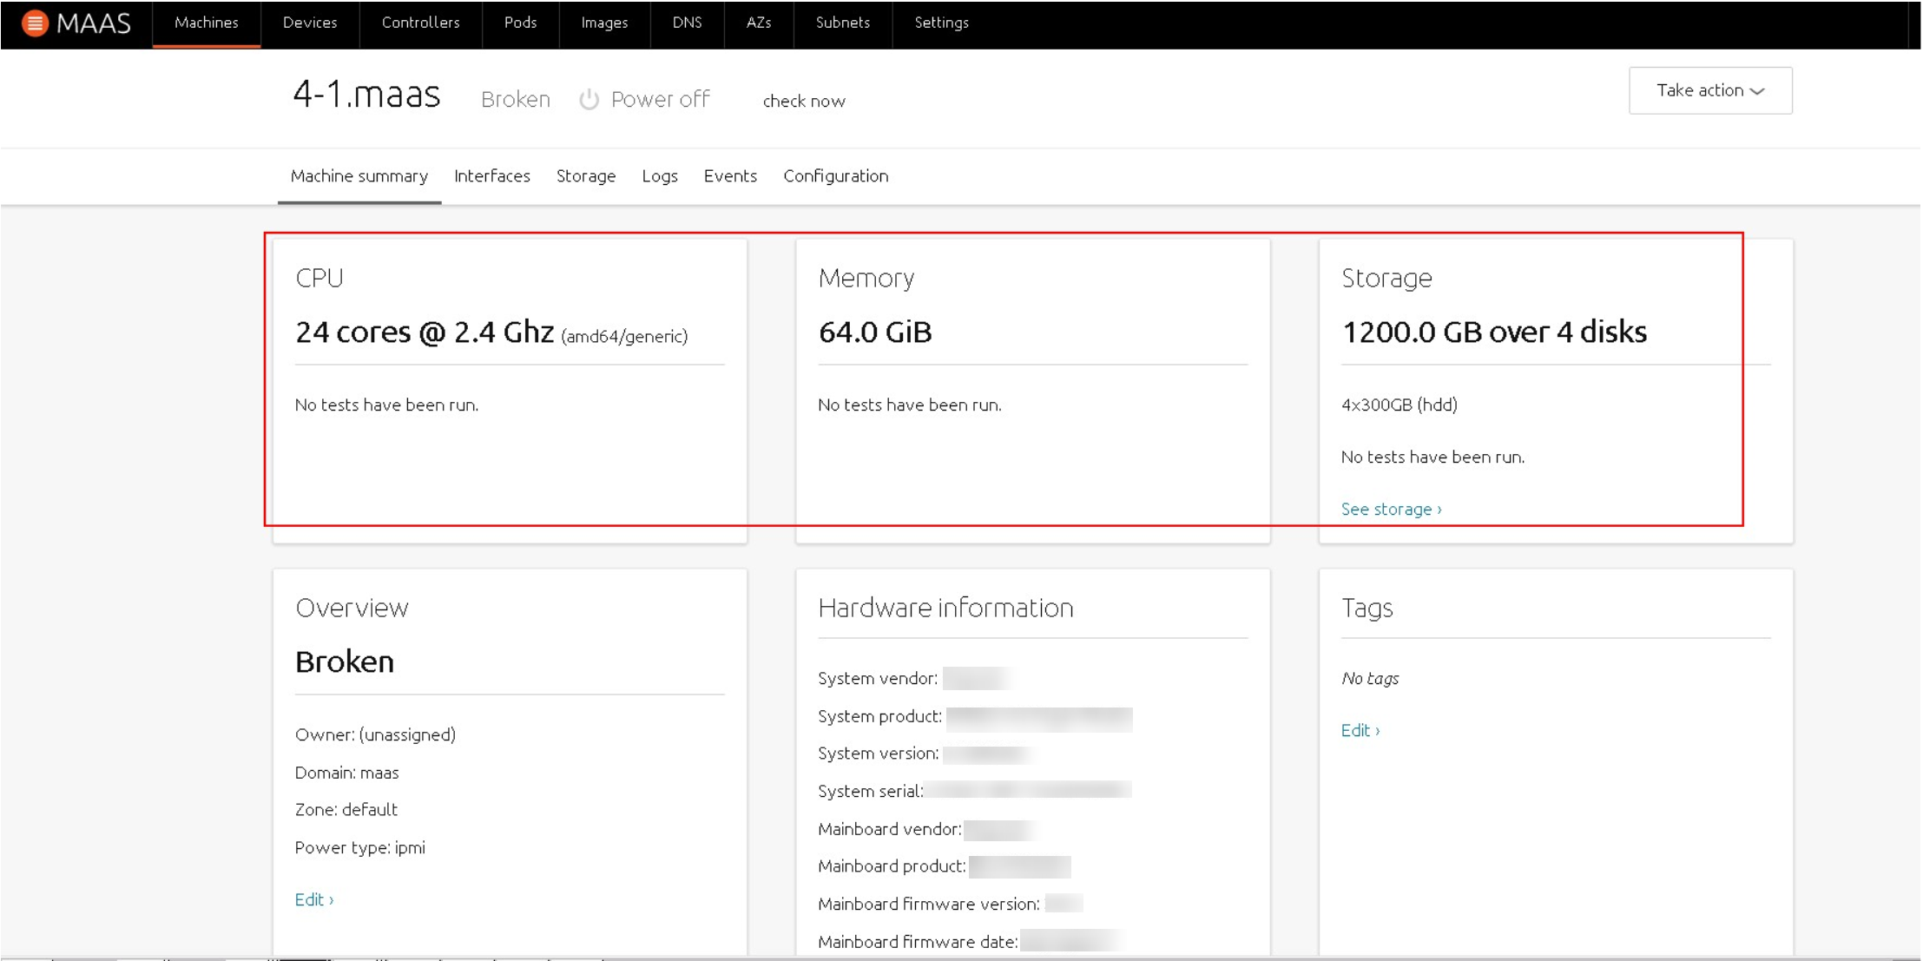

The actual server information is as follows.

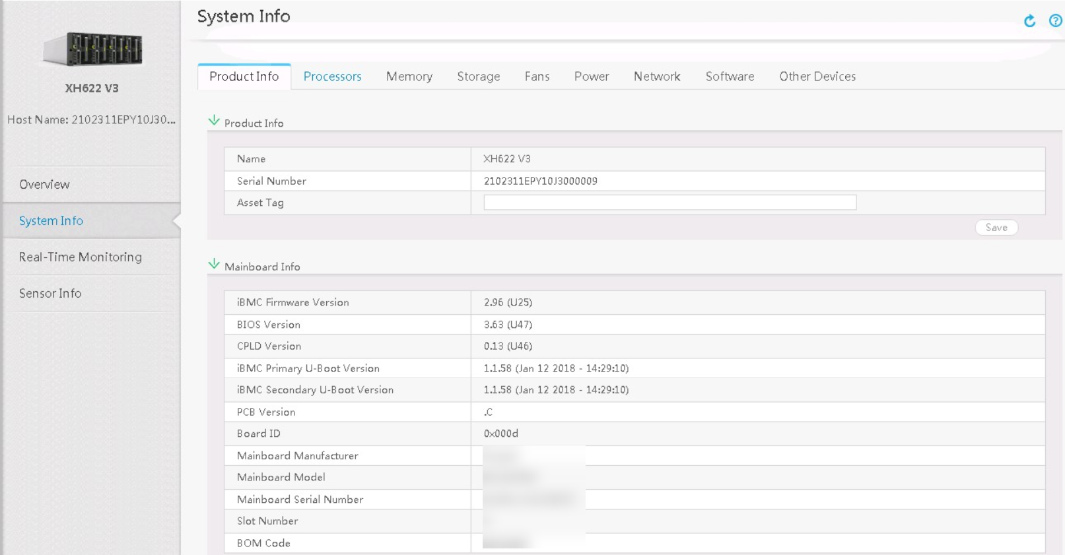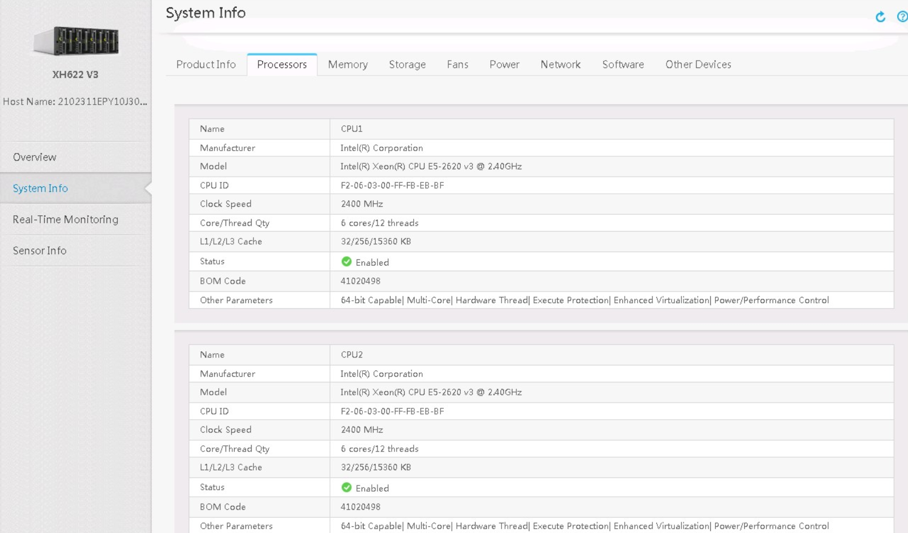

# Deploying the PXE System

1. Access the OS for which the PXE boot mode needs to be deployed, and choose **Take action** > **Commission**.

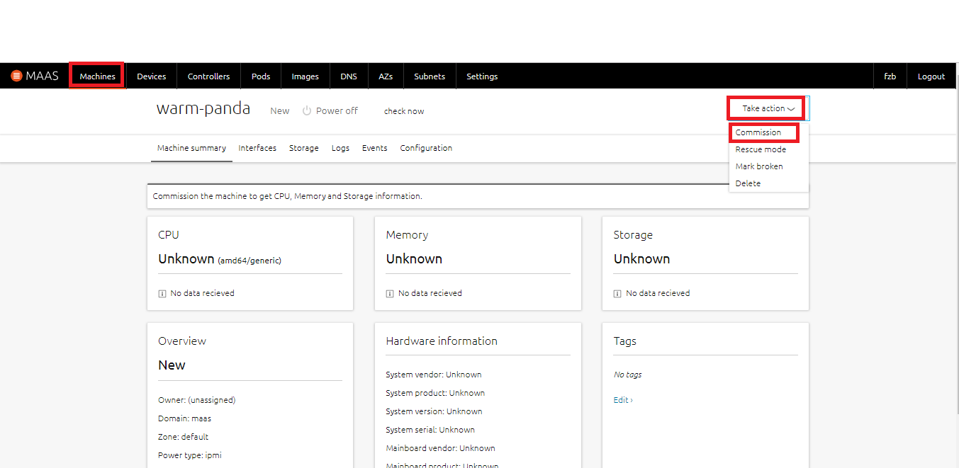

2. After the deployment starts, the **Commissioning** operation will be performed for all items. After all items are passed, the **Hardware tests** operation will be performed.

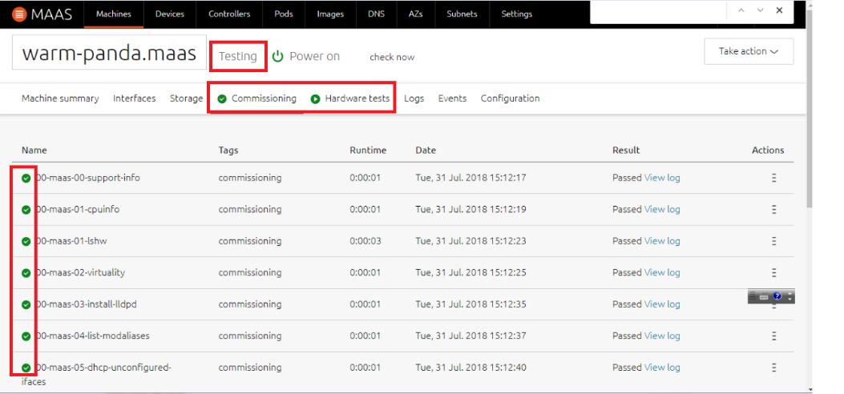

After the deployment is successful, the status changes to **Ready**.

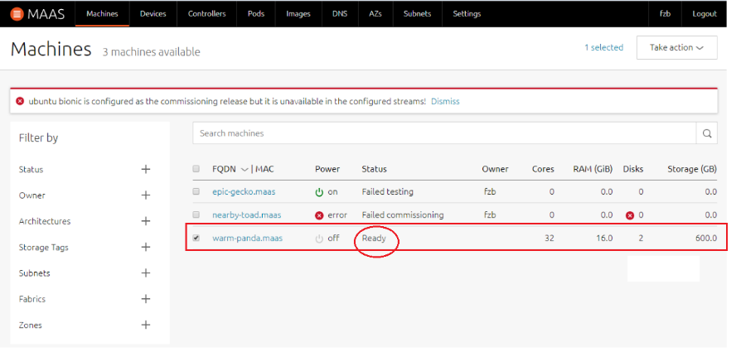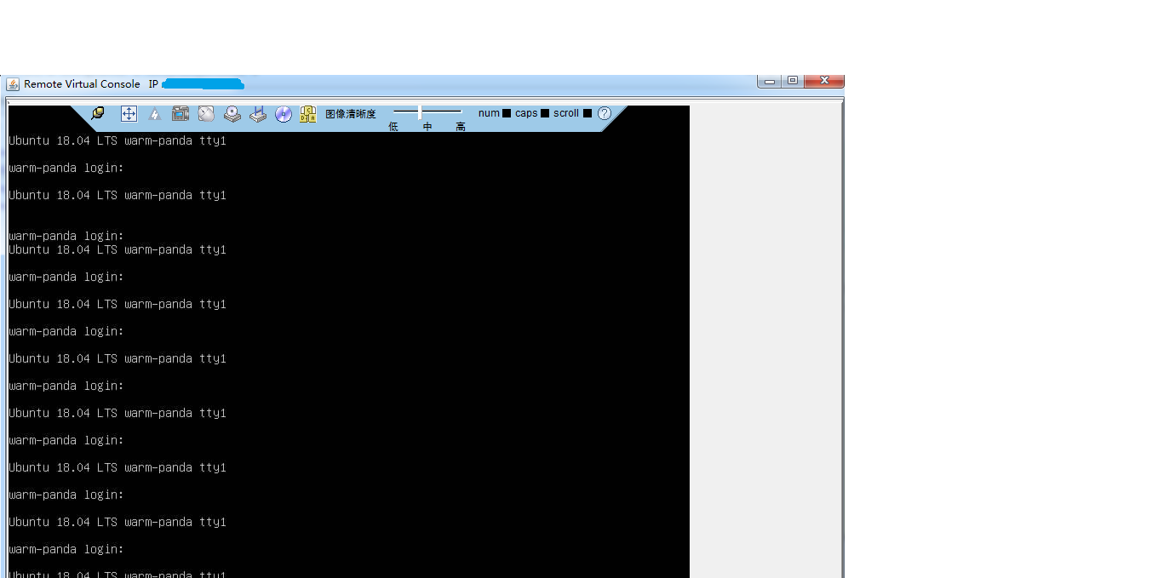

# Deploying the Image System

1. On the **Machines** page, select the server where the system is to be installed, and choose **Deploy** in the upper right corner.

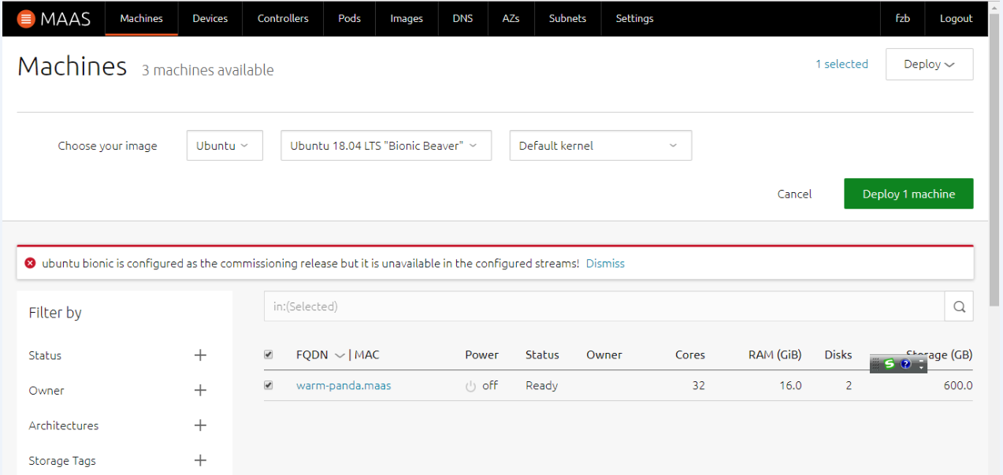

2. The system deployment starts. The status changes to **Deploying Ubuntu 18.04 LTS**.

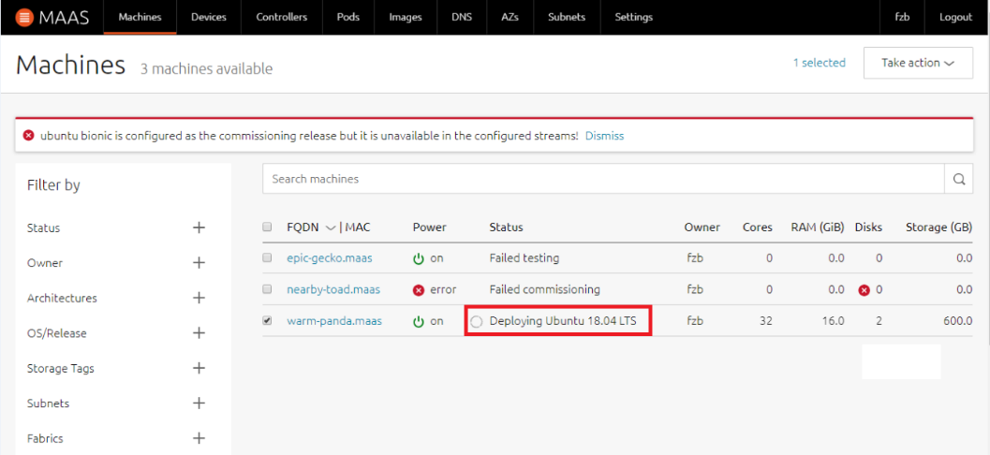

3. After the deployment is successful, the status changes to the name of the installed system (**Ubuntu 18.04 LTS**).

